**Home Page:-**

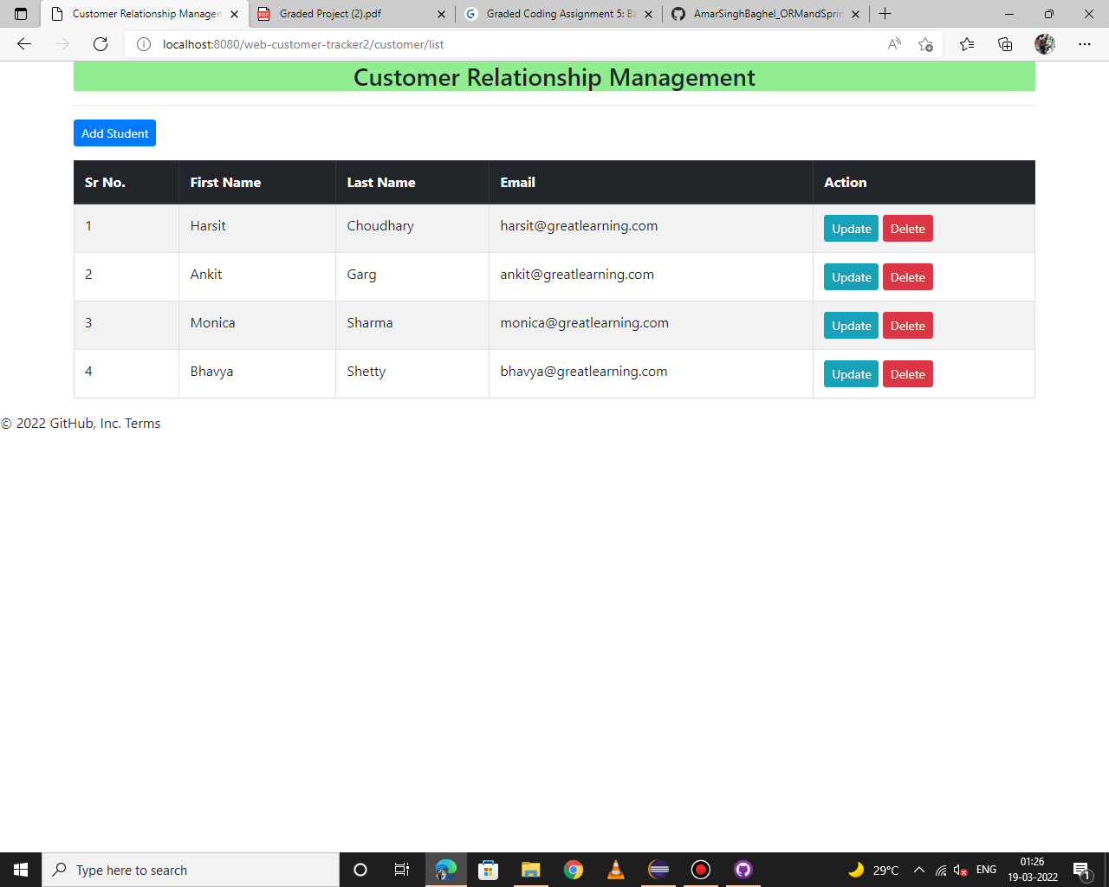

**Add Customer New customer form:-**

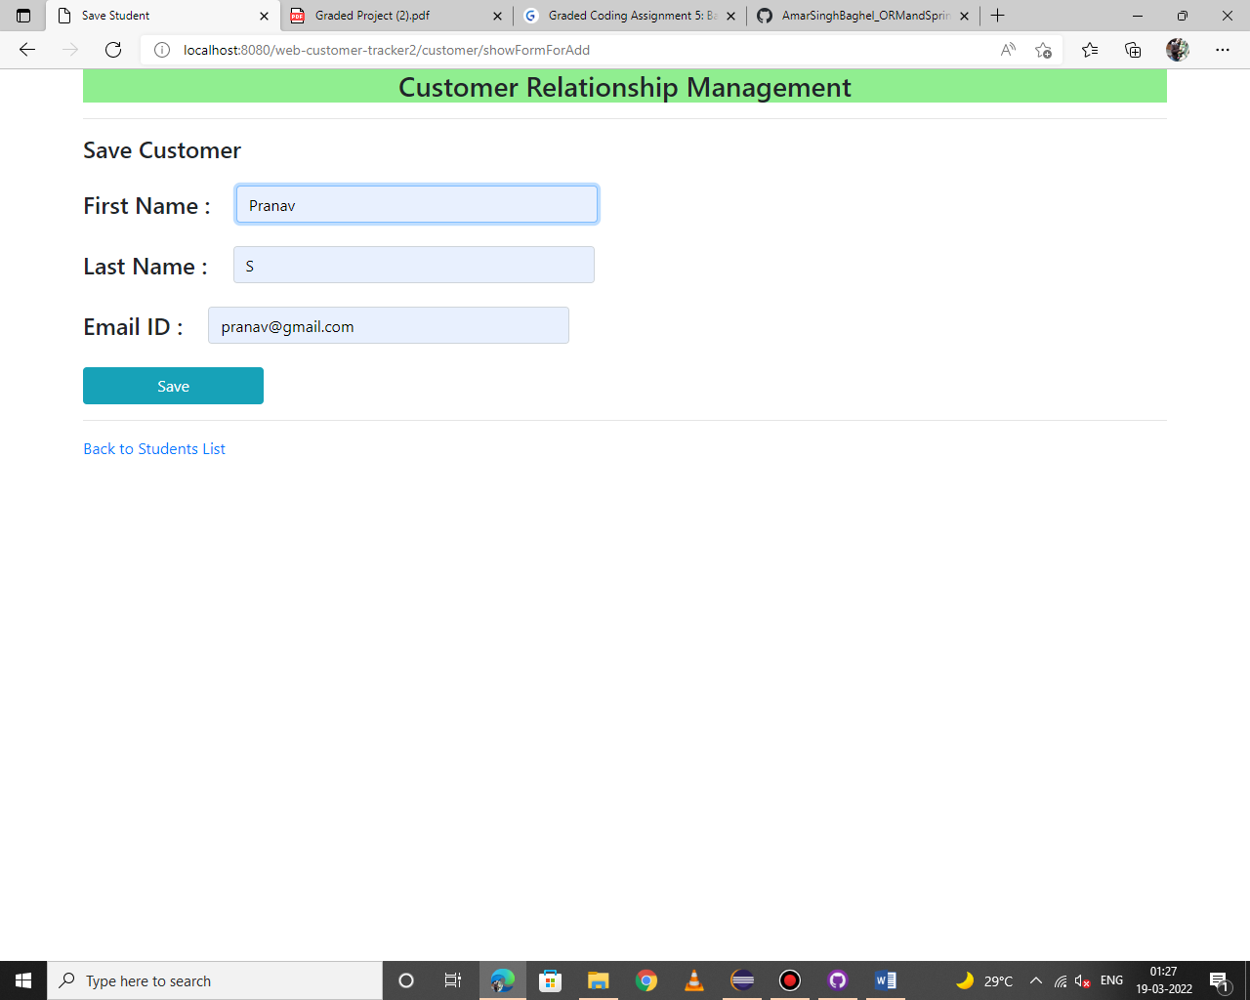

A

**Updated list of customers after adding a new customer Pranav S.:-**

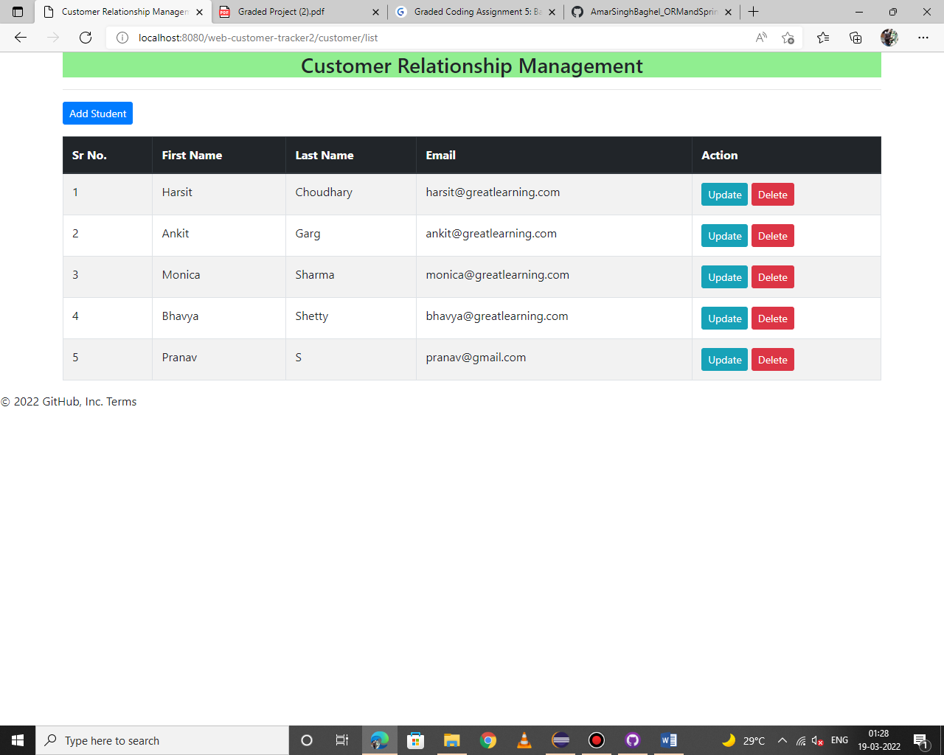

**Updating the email address for customer Harshit Choudhary and saving it with address harsit@gmail.com :-**

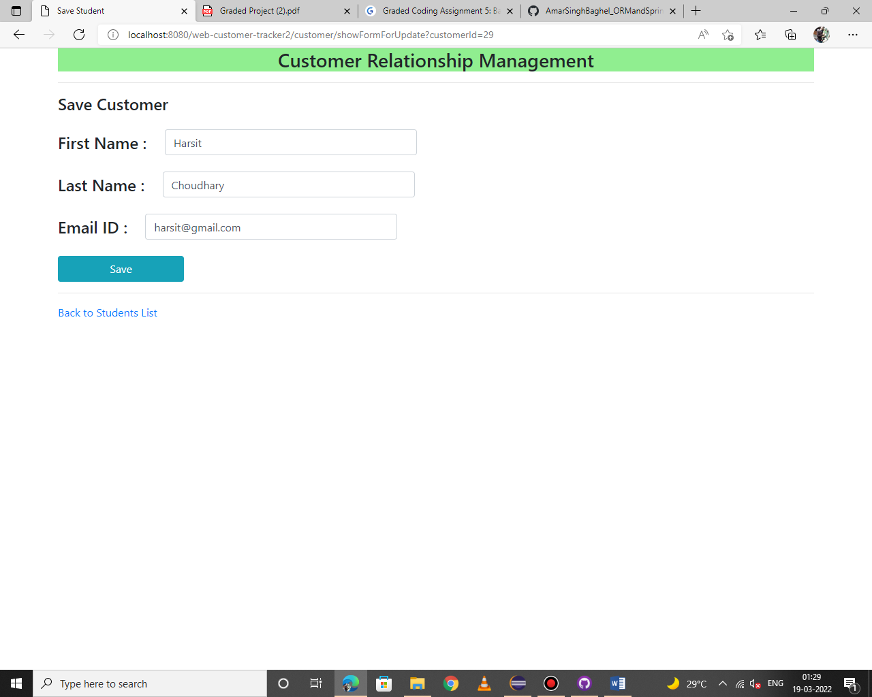

**Updated value of Customer Harsit Choudhary with email address ending with gmail.com**

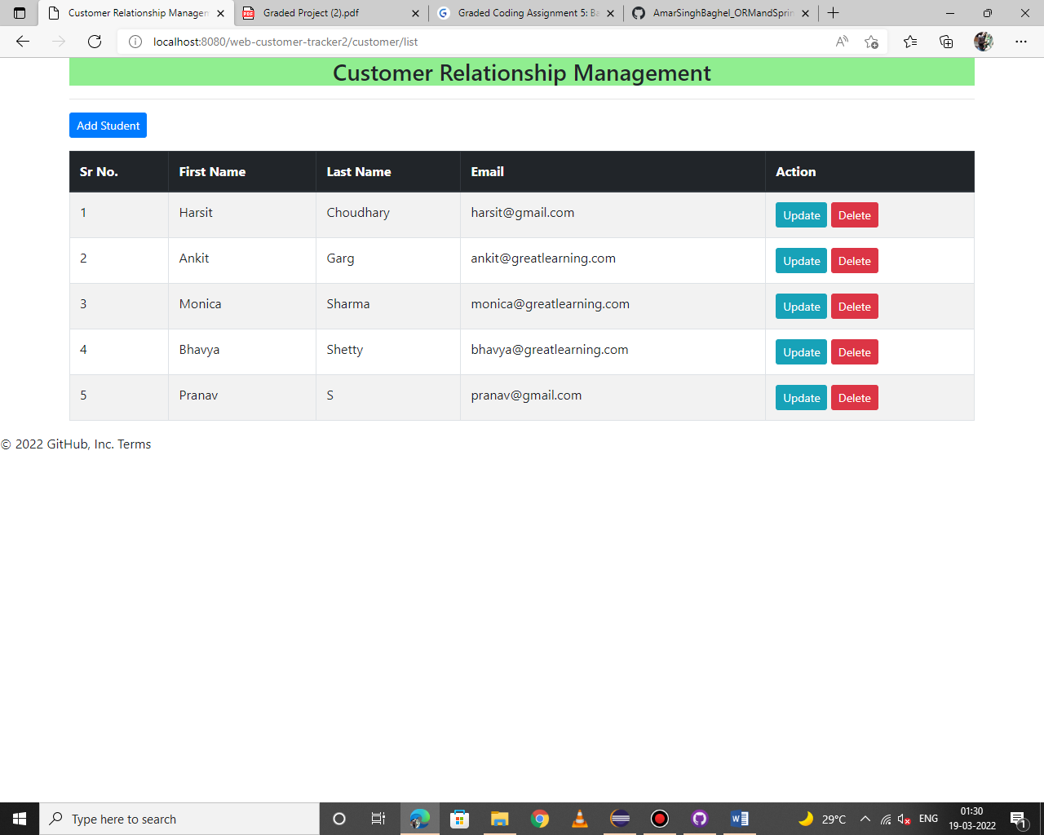

**upon clicking the delete button, a pop up is generated.**

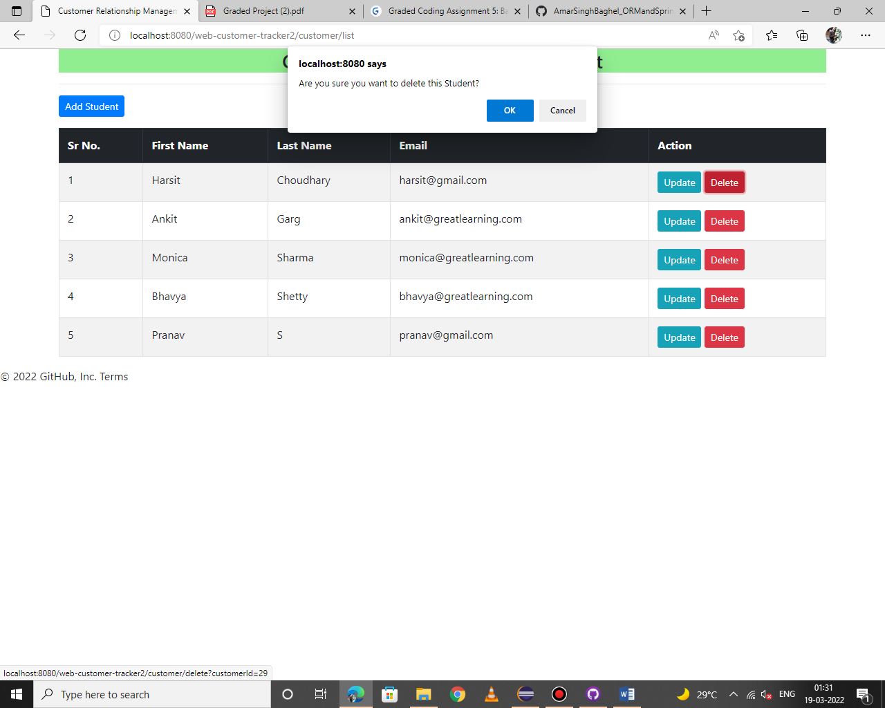

**Updated list of employees upon deleting customer Harsit Choudhary**

